KTH FS project about seaweed utilization in Kenya

Before arrival
When I saw students who had gone on KTF FS/MFS in previous years, I was very inspired to go as well, thanks to what an incredible opportunity it is to discover new countries and meet people from other parts of the world. When the time came to apply, there was no hesitation! We were quite late, about 2–3 weeks before the application deadline, but it still worked out great (except for a bit of writing stress). We contacted many different companies and supervisors, and we found a fun project in Kenya that collaborated with women's cooperatives growing seaweed on the southern coast. It felt incredibly exciting to explore a country like Kenya, and at the same time, Africa. We booked our plane tickets and applied for visas. Elsa and I also had to get several vaccinations before the trip, but I’d say it was worth it, better that than getting sick! Booking accommodation shortly before the trip went very well, we used Booking a lot. Apart from that, we were just getting hyped up for the journey!

Upon arrival
We arrived in Kenya on March 20th, a few days before our project started. We landed in Nairobi and took the train toward Mombasa. In Diani, we were welcomed by our contact person, who took us down to the seaweed farms in the coastal towns and introduced us to the people we would later be working with. We had a lot of freedom in our project and were able to decide for ourselves who we wanted to talk to and interview, which was really fun. Everyone was incredibly kind and hospitable, we felt truly welcomed everywhere we went. We stayed in Kenya for a little over 8 weeks.
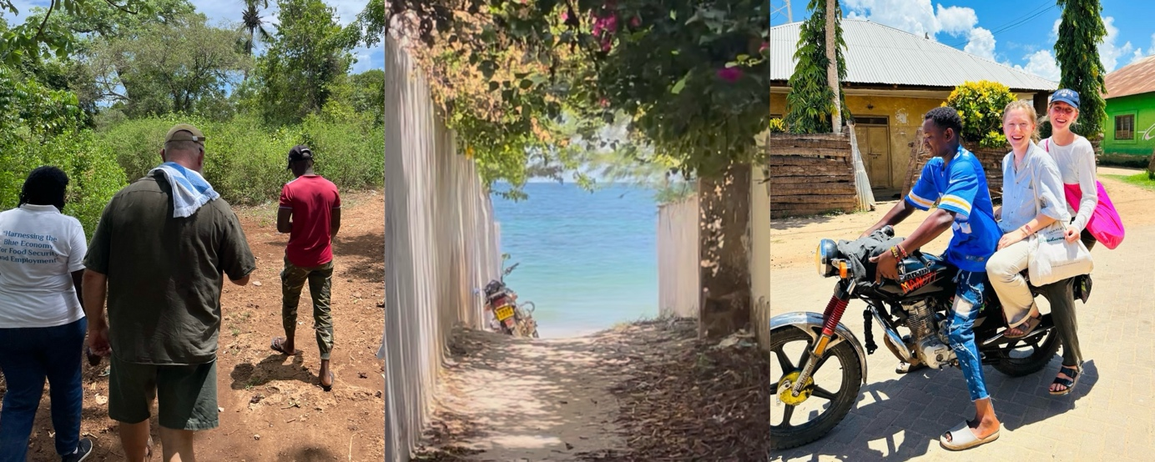

Financials
In general, things were much cheaper in Kenya than in Sweden. Most things were more affordable, everything from accommodation to food and transport. We saved some money by choosing places to stay that had their own kitchens, where we cooked most of our meals ourselves. Fresh fruit like mangoes, papayas, pineapples, and vegetables were sold along the roads everywhere, and we bought a lot of it. Tasty, affordable, and at the same time a way to support the local people!
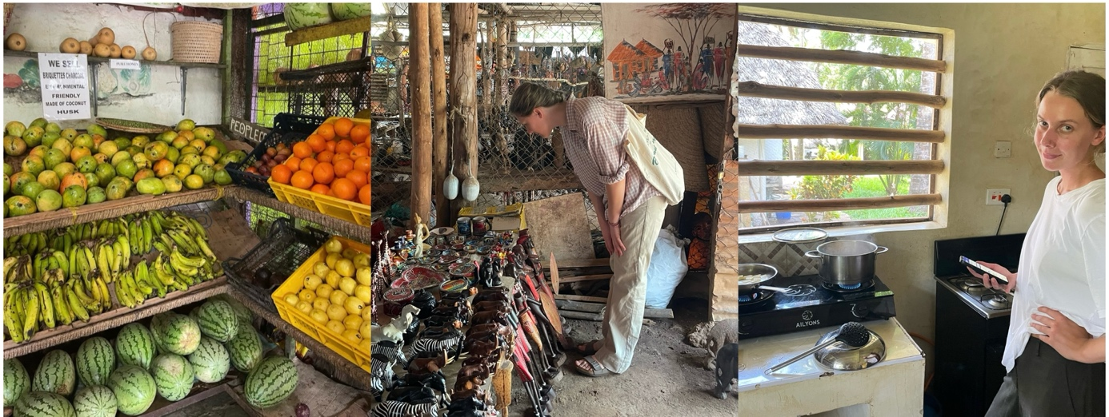

Accommodation
We found accommodation through Booking. Diani, where we stayed, is a tourist destination, so there were many different places to choose from. We moved around between several locations, both because it was fun to explore and because we were collecting interviews in different villages along the coast. It was a great experience! The condition of the accommodation depended on how much you paid, but you could stay very comfortably for quite a low price. Having air conditioning and good mosquito nets was really nice because of the heat and the large number of mosquitoes...
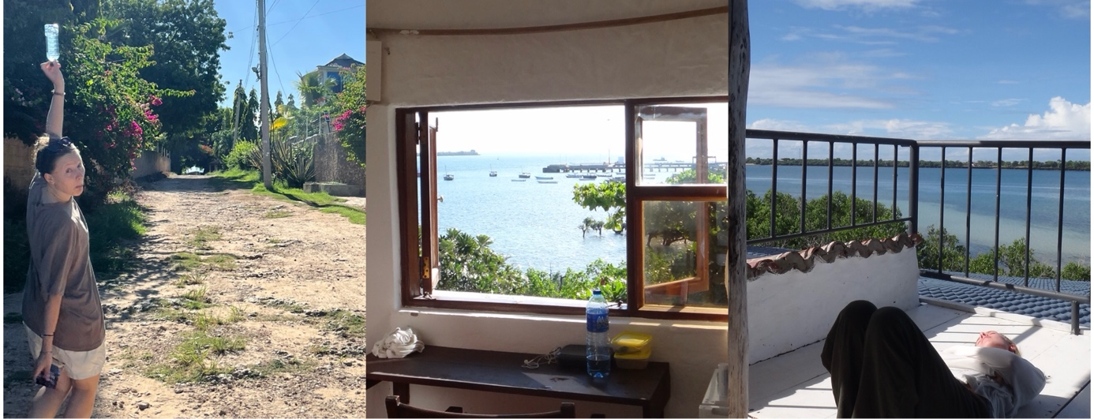

Project
In southern Kenya, in Kwale County, seaweed is farmed in small villages along the coast. The dried seaweed is currently exported to the USA or Europe, where it is processed into thickening agents (carrageenan) used in food and cosmetics! Our project explored ways to benefit the local communities more than the limited income currently gained from exports. This could involve expanding the local production of already existing products (such as soap, shampoo, and lotion), or starting to produce fertilizer, animal feed, and medicine from the seaweed for local use. It could also include introducing seaweed as a food source.
A typical day consisted of some writing, short trips to different locations, or conducting interviews. Some days were more relaxed than others, allowing for longer excursions or just chilling at the beach! At the end of our trip, we presented our findings to the institute we had collaborated with. A group of staff members attended, listened, and gave feedback. It was very nervous, but truly rewarding and brought really valuable responses to our work!
Our local contact provided a lot of support: always being available for tips, advice, and offering a general sense of security on site.
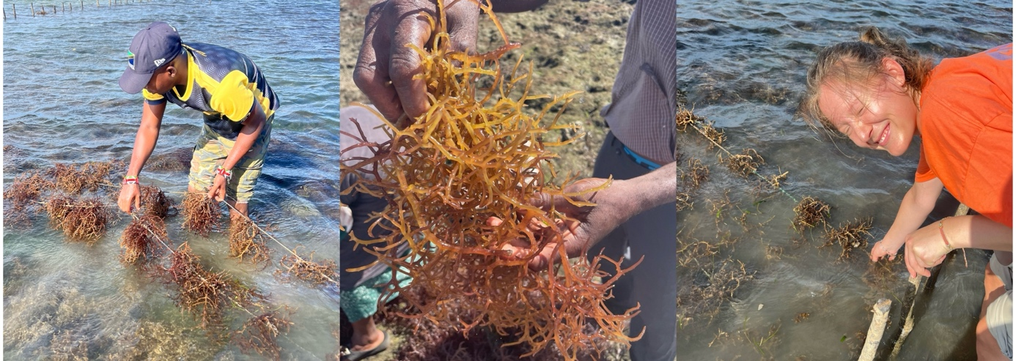

Country
Kenya is an amazing country, where the people are incredibly welcoming, warm, and social. Many wanted to talk to us, and everyone was very outgoing. The nature is absolutely magical, with red soil, lush greenery, the Indian Ocean stretching along the entire coast, and beautiful sunrises and sunsets. Monkeys were running around everywhere, and the streets were full of tuk-tuks. It wasn’t hard to get help with things we needed support with, people were very helpful.
We experienced a bit of culture shock at first, as society is much more outgoing and social than it is back home in Sweden. We were also in a well-known tourist destination, which meant that a lot of vendors approached us trying to sell things. That decreased in less touristy areas.
We also stood out, as there weren’t many other tourists where we were. This meant we got a lot of attention, which felt unfamiliar at first. But eventually, we got used to it, and everyone was incredibly kind and hospitable. We got to know many friendly local people.
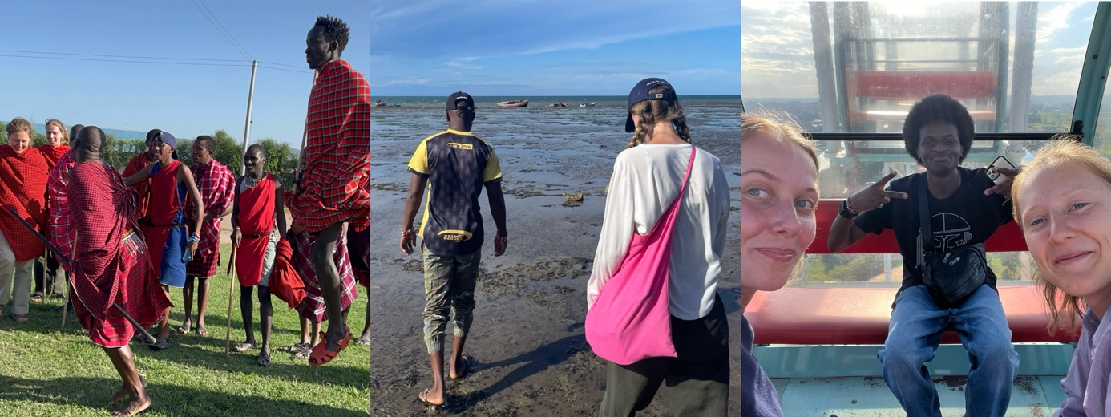

Leisure and social activities
In our free time, we explored different places and villages in the surrounding area. It was incredibly easy to get a tuk-tuk, and we visited villages around Diani (such as Gazi and Shimoni). In Kenya, most people are religious, with the majority being Christian Catholics, and one Sunday we attended a Sunday Service at a church in Diani. It was an amazing experience, they sang several beautiful Swahili songs, and we were warmly welcomed and included, even dancing with everyone in the church. It was easy to get to know the locals, as they are so incredibly social and welcoming.
During our time in Kenya, we went on two safaris - one to Tsavo East National Park (2 days) and one to the Maasai Mara (3 days). We would both say it was the most fun thing we’ve ever done. Maasai Mara probably takes the top spot among the parks. Both parks had absolutely stunning nature, were full of animals, and the lodges we stayed at in the middle of the parks were incredible, with elephants and hippos just outside our rooms.
I would highly recommend anyone visiting Kenya to go on a safari - it’s probably the most amazing and exciting thing I’ve ever done!
We also spent a week in Nairobi at the end of our trip, which was a complete contrast to the coastal life in Diani, and a fantastic city. We visited the National Museum, explored the city, spent time with Kenyan students we had met through KTH, and also did the Maasai Mara safari during that time. We visited a Maasai village as well, which became one of the highlights of our entire stay in Kenya.
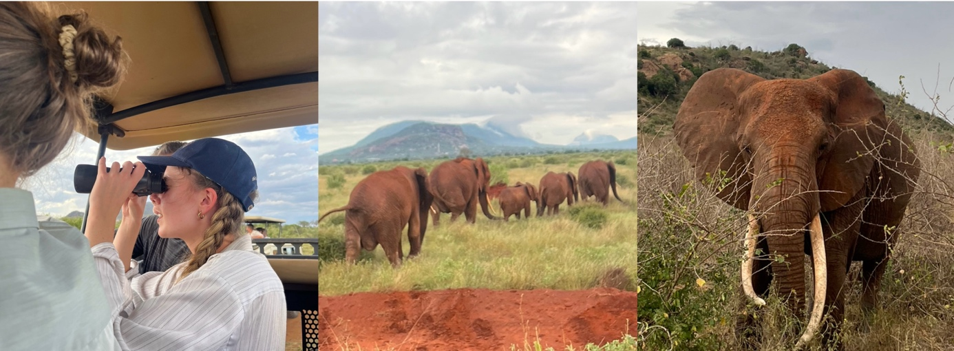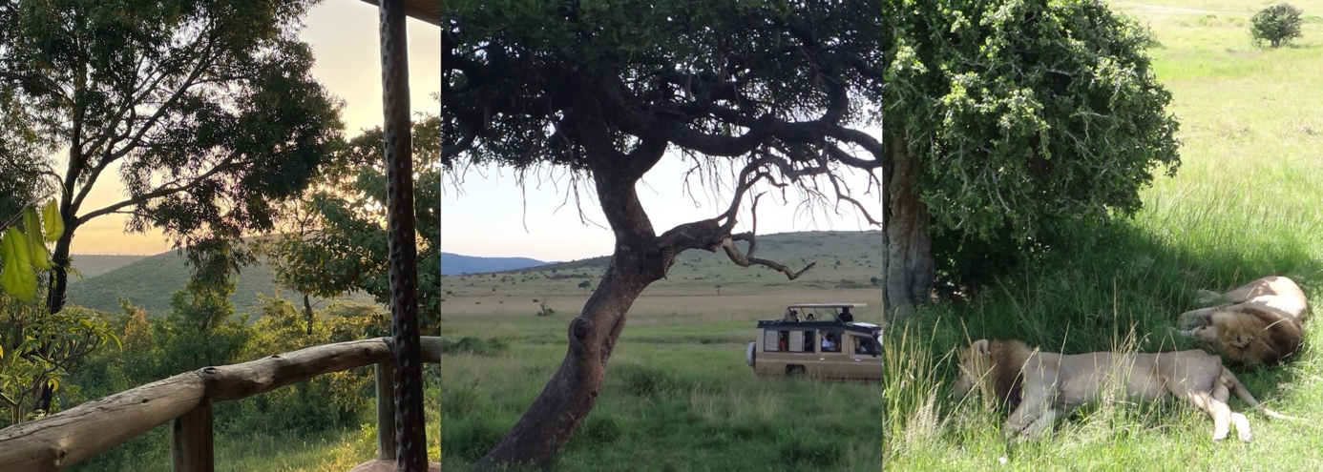

Sustainability
We traveled as sustainably as we could in Kenya, using trains for domestic travel instead of flying. The most common mode of transportation in Diani was tuk-tuks, which unfortunately run on fossil fuels, reducing overall sustainability.
Apart from transport, it’s likely quite possible to live fairly sustainably in Kenya, as materialism and overconsumption are nowhere near as widespread as in the Western world. Much of the food - especially fruits and vegetables - is locally produced in Kenya. The biggest challenge to sustainability is likely the reliance on fossil-fueled vehicles and transportation. Our project primarily addressed Global Goals 5, 8, 12, and 14, and aimed to contribute to increased sustainability within the Kenyan seaweed industry.

Other recommendations and observations
I would recommend reading up a bit on the country and culture of the place you're going to, to avoid too much of a shock upon arrival. It’s far from home, and there are major differences — something I didn’t think much about before I left, which led to a bit of culture shock. At the same time, you can’t prepare for everything — there will be some level of shock no matter what.
In Kenya, many people live below the poverty line, and it brings up difficult emotions when you witness those living conditions. It’s worth being mentally prepared for that. As a tourist in Kenya, you also get a lot of attention because of your skin color - you stand out, and vendors and others often approach you in the streets. But it’s something you get used to after a while, and the vendors were never rude.
